**UNIVERSITY OF ENGINEERING AND TECHNOLOGY, LAHORE**

**(NAROWAL CAMPUS)**

**­**

**NAME :**

**ABDULAHAD HUSSAIN**

**ROLL NO. :**

**549**

**SECTION:**

**A**

**SUBJECT:**

**PROGRAMING FUNDAMENTAL**

**LAB #10:**

**Program No. 01:**

**Statement:**

Write a program that inputs temperatures of seven

days of a week and calculates its average.

**Source Code:**

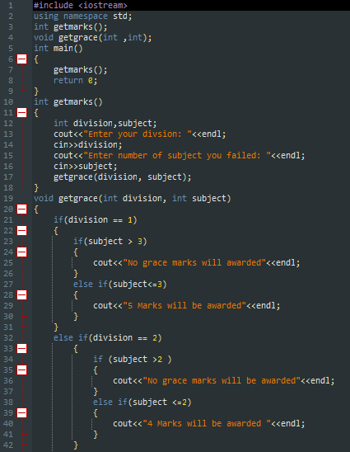

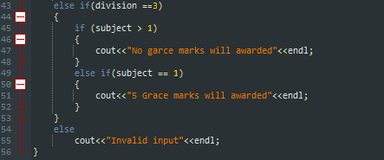

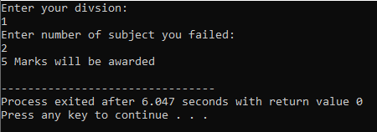

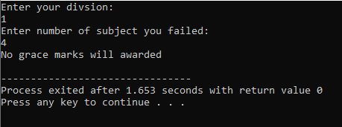

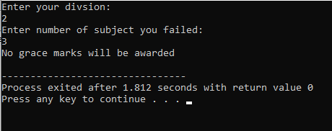

**Flow Chart :**

**Program No. 2:**

**Statement :**

Write a C++ program to copy in reverse order the elements of an integer 1-D array into another array of same kind.

**Source Code:**

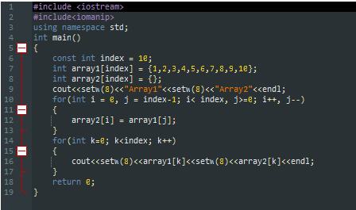

**Output:**

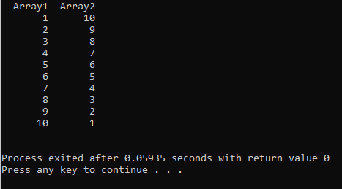

**Flow Chart:**